**Target Group:** Class Coordinator

**Instructor :** Manisha Tiwari, Bimala Budathoki

**Faciliated by:** Ashraf Ali Miya, Jasmina Pulami

**Time** : 4:15 PM onwards

**Place :** Computer Lab

**Phase-1**

**1. Basic Course :**

1. **Opening & Closing Computer**
2. **Using of Mouse( Left click and right click)**
3. **About taskbar & icon**
4. **Searching File, folder and software**
5. **Creating new folder,**
6. **Rename new folder,**
7. **Delete folder**
8. **Use of recycle bin**
9. **About local D,**
10. **Local E, downloads ,documents picture etc.**
11. **Copy, Cut & Paste**
12. **Use of minimize, closing and full screen**
13. **typing lowercase, Uppercase, symbol and numbers**

**Plan:**

**1. Keeping daily progress report:**

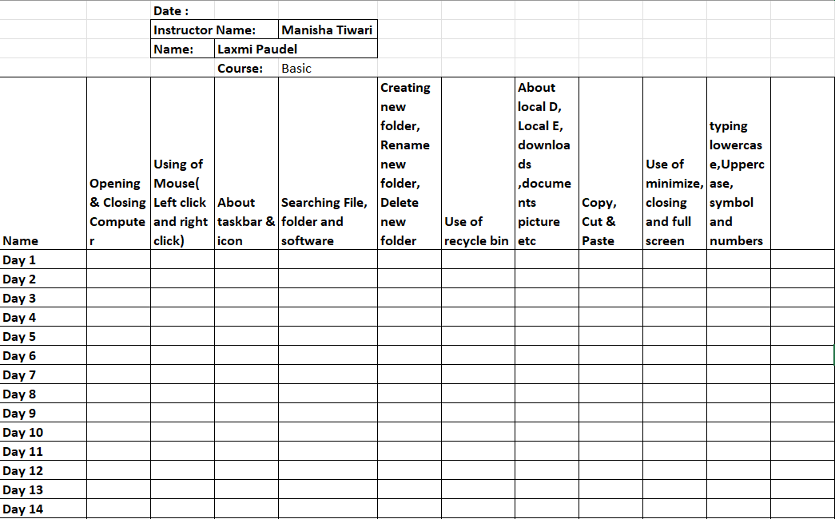

**2. Giving practice question**

**3. Maintaining Notes**

**4. Certifications**

**5. Evaluation point.**

**Phase-2**

**2. Mid-Level Course:**

a. Opening word,

b. Saving file

c. opening word

d. save file

e. typing

f. font size

g.BIU

h. color changing

i. sub script,superscript

j. Layout

k. InsertTab

l. Printing

Plan:

1**. Giving practice question**

**2 . Maintaining Notes**

**3. Creating Worksheet**

**4. Printing worksheet**

**5. Meeting on progress report.**